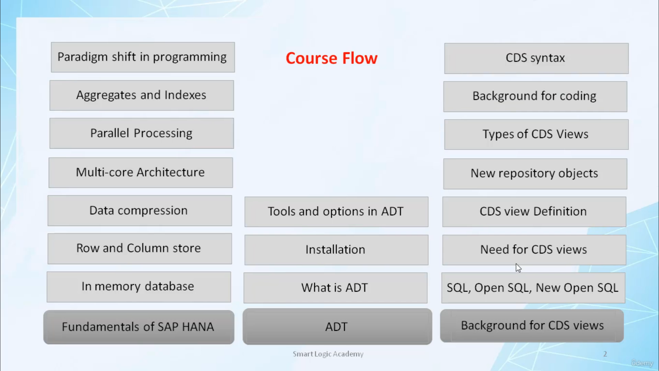

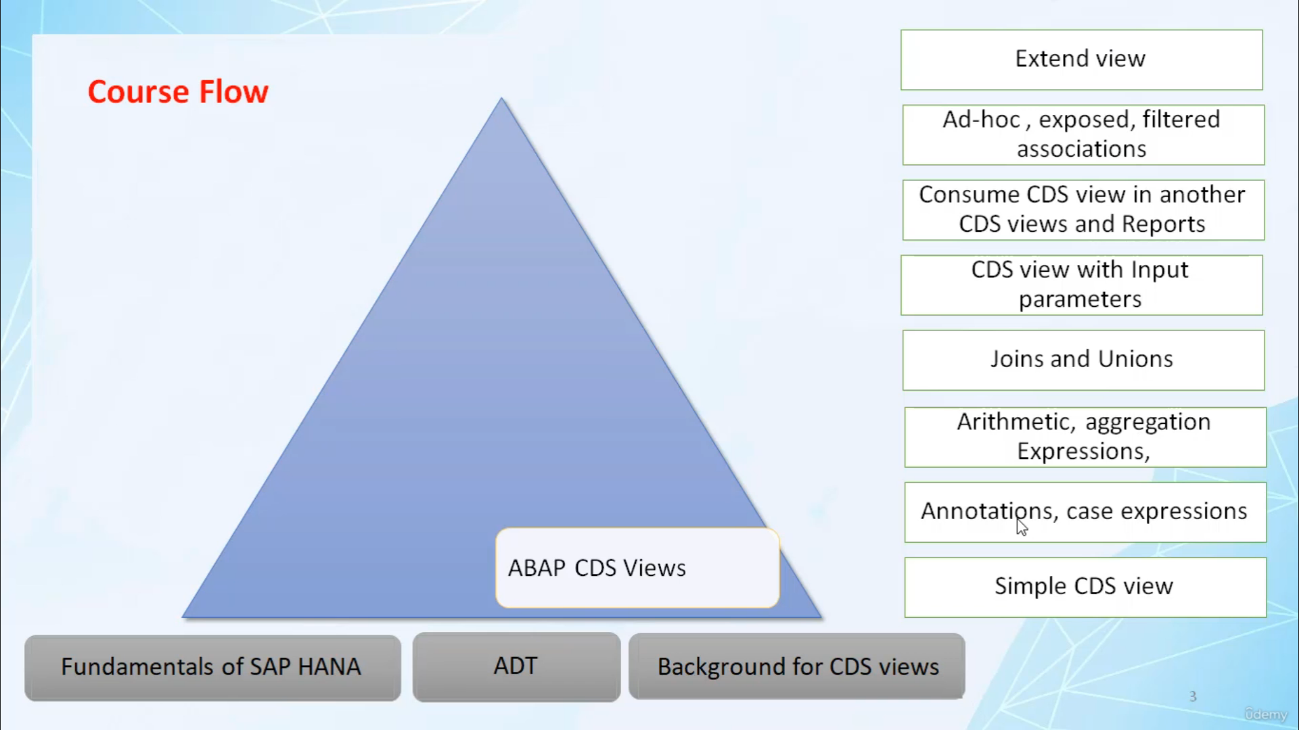

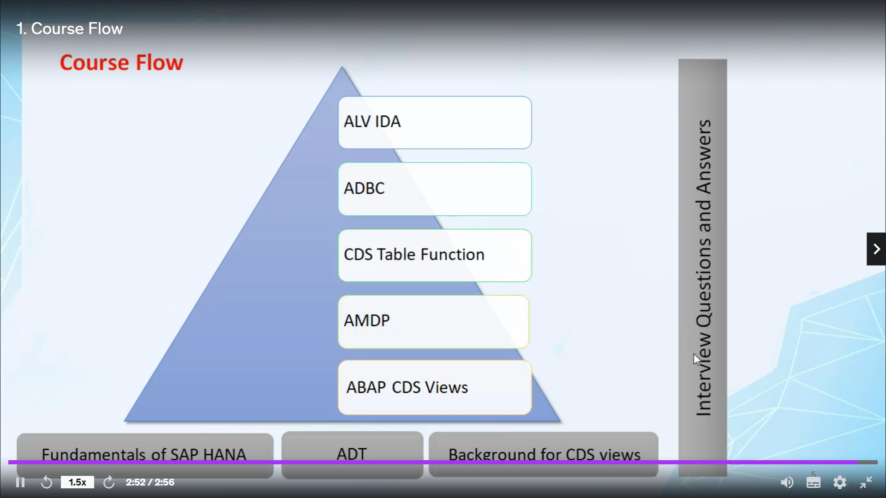

Thank you for enrolling into ABAP for HANA course. Let's see the course flow. At the very beginning of this course. I will explain fundamentals of SAP HANA, here

I will cover topics, in memory database, row & column stores, data compression, multi-core architecture, parallel processing, aggregate and indexes and then, at last, I will explain to you how SAP HANA brings a paradigm shift in programming approach.

Then I will explain to you, What is (ADT) ABAP development tool. how you can install eclipse and then plug-in ADT. I will explain to you about the tools and options available in ADT. then I will cover background for CDS view, here I will explain to you what new SQL and its advantage over open SQL is, need for CDS view, CDS view definition, new repository objects, types of CDS views, then I will cover the background for coding and CDS syntax. After covering all these topics, I will tell you what ABAP CDS view is, here

I will explain how you can create simple CDS view, CDS view with annotation and case expressions, CDS views with arithmetic and aggregation expressions, how you can use joins and unions in ABAP CDS view,

how to create CDS view with input parameters, how you can consume CDS view in another CDS view and report, then I will explain to you about the associations in ABAP CDS view and their types.

Then, at last, I will explain how you can extend ABAP CDS view without any modification into original CDS view, then we will learn AMDP ( ABAP managed database procedures ), here I will explain to you what is AMDP and how you can create it. then I will explain to you what CDS table function is and how you can create it.

After this, I will explain to you, what is a ADBC and how you can create it. And at last, I will explain to you what is ALV with IDA and how it is different from conventional ALV. then, at last, I will provide you articles with interview questions and answers so that you can prepare yourself to get a new job.